JAY PRAKASH PANDEY (IT_2ND YEAR, A-44)

12019002004044

**ABSTRACT**

Home fires have been taking place frequently and the threat to human lives and properties is growing in recent years. Liquid petroleum gas (LPG) is highly inflammable and can burn even at some distance from the source of leakage. Most fire accidents are caused because of a poor-quality rubber tube or the regulator is not turned off when not in use. Therefore, developing the gas leakage alert system is very essential. Hence, this paper presents a gas leakage alert system to detect the gas leakage and to alarm the people onboard.

The data from NCRB 2011-2014, LPG gas bursts have claimed 19491 lives in 5 years in India. LPG is widely used in Indian kitchens. Most of the residential fire accidents in India are caused by LPG, recently in our village fire accident ruins the life of 20 family.

Keywords: Liquid petroleum gas, Gas sensor, Leakage, National crime records bureau

# OBJECTIVES

Gas leakage leads to various accidents resulting in both material loss and human injuries. The risk of explosion, firing, suffocation is based on their physical properties such toxicity, flammability, etc. The number of deaths due to explosion of gas cylinders has been increasing in recent years. The reason for such explosion is due to substandard cylinders, old valves, worn out regulators and lack of awareness in handling gas cylinders. The LPG or propane is a flammable mixture of hydrocarbon gases used as fuel in many applications like homes, hostels, industries, automobiles, vehicles because of its desirable properties which include high calorific value, less smoke, less soot, and meager harm to the environment. Natural gas is another widely used fuel in homes. Both gases burn to produce clean energy, however there is a serious problem of their leakage. Being heavier than air, these gases do not disperse easily. It may lead to suffocation when inhaled and may lead to explosion [1]. Due to the explosion of LPG, the number of deaths has been increased in recent years. To avoid this problem there is a need for a system to detect the leakage of LPG. Gas leak detection is the process of identifying potentially hazardous gas leaks by means of various sensors [2]. Several designs of LPG detection and alert system have been proposed in the literature. Apeh et al. designed kitchen gas leakage detection and automatic gas shut off system [3]. T.Soundaryaet al. presented the cylinder LPG gas leakage detection system [4]. Wireless and GSM technology [5] based gas detectors have also been proposed. This paper presents an LPG leakage detection and alert system to avoid fire accidents and to provide house safety. The rest of the paper is organized as follows. Section 2 presents the LPG leakage detection and alert system and Section 3 concludes the paper.

# METHODOLOGY

Kitchen safety device is simple circuits and easy to install,

The LPG leakage detection and alert system presented in this section is a simple as shown in Figure 1, yet reliable. It is battery operated and hence portable. It is designed in such a way that it can also be operated with ac power supply. To support the latter case, it has a bridge rectifier with a capacitor filter. This is followed by a regulator designed with IC7805 which provides +5V regulated power supply. Figure 1: LPG leakage detection and alert system to detect the LPG, MQ-6 gas sensor is employed. This sensor can be operated at +5V. The sensitivity of this sensor is very high and it has quick response time. It can detect the LPG concentration in the range of 200-10000ppm. The gas sensing layer of this sensor is made of Tin Dioxide (SnO2) and gold (Au) electrodes. The output of the gas sensor is given to LM358 dual operational amplifier where it is compared with the threshold value for gas density which is set using preset potentiometers and amplified. If the sensed voltage is greater than the preset threshold voltage, the operational amplifier output fires the driver circuit for LED and Buzzer. As a result, the LED will glow and the buzzer starts to produce alarm sound.

MATTERIALS

ARDUINO,MQ2 SENSOR,BREADBOAD,BUZZER,RESISTOR,LED

  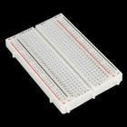 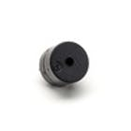   

TUSHAR AGARWAL(IT_2ND YEAR, A-47)

12019002004047

the code gets indicates values and pins then it indicates the threshold value of the smoke (it is the value that if the sensor senses above it start to alert the person that there is smoke) Then it sets up outputs and inputs. After that, it starts the loop, in the loop, there is 2 possible outcomes: 1-it stays in the threshold value 2- it goes above the threshold value. If it stays in the threshold value the green led will be on while the buzzer and red led will be off. If it goes above the threshold the green led will turn off and the red led and the buzzer will turn on.

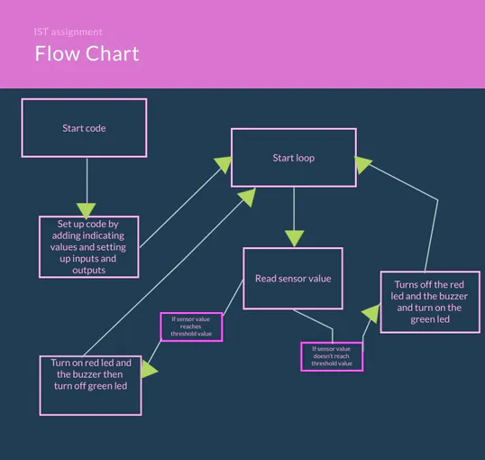

**RESULT and FUTURE**

Kitchen safety is very light weight, cheap and can be install anywhere in kitchen. It detects the gas and alert us with alarm. Its life span is about to 15 years, the accuracy is 98%,

It results to prevent the fire in kitchen, it is difference from fire alarm which only use temperature while it uses gas sensor as well as temperature sensor, it can be also used in factories and LPG store.

It can improve wit adding iot and GUI to mobile device, auto fire call and it can also improve by increasing the accuracy more.

[click for result](https://www.tinkercad.com/things/c7dM41Smmuj-gas-detector/editel)

**CONCLUSION**

Gas leakage leads to severe accidents resulting in material losses and human injuries. Gas leakage occurs mainly due to poor maintenance of equipment’s and inadequate awareness of the people. Hence, LPG leakage detection is essential to prevent accidents and to save human lives. This paper presented LPG leakage detection and alert system. This system triggers LED and buzzer to alert people when LPG leakage is detected. This system is very simple yet reliable.

**REFERENCES**

[1] Mahalingam, A., R. T. Naayagi, and N. E. Mastorakis. "Design and implementation of an economic gas leakage detector." Recent Researches in Applications of Electrical and Computer Engineering, pp. 20-24, 2012.

[2] Attia, Hussain A., and Halah Y. Ali. "Electronic Design of Liquefied Petroleum Gas Leakage Monitoring, Alarm, and Protection System Based on Discrete Components." International Journal of Applied Engineering Research, vol. 11, no. 19, pp. 9721-9726, 2016.

[3] Apeh, S. T., K. B. Erameh, and U. Iruansi. "Design and Development of Kitchen Gas Leakage Detection and Automatic Gas Shut off System." Journal of Emerging Trends in Engineering and Applied Sciences, vol. 5, no. 3, pp. 222-228, 2014.

[4] T.Soundarya, J.V. Anchitaalagammai, G. Deepa Priya, S.S. Karthick kumar, “C-Leakage: Cylinder LPG Gas Leakage Detection for Home Safety,” IOSR Journal of Electronics and Communication Engineering, vol. 9, no. 1, Ver. VI, pp. 53-58, Feb. 2014.

[5] Ashish Shrivastava, Ratnesh Prabhaker, Rajeev Kumar, Rahul Verma, "GSM based gas leakage detection system." International Journal of Emerging Trends in Electrical and Electronics, vol. 3, no. 2, pp. 42-45, 2013.

**Contacts**

[**mailto: JAY PRAKASH PANDEY**](mailto:jayprakashpandeya082@gmail.com)

[**mailto:TUSHAR AGARWAL**](mailto:tusharitf36@gmail.com)